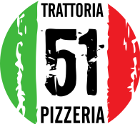 Christmas Day Menu @ Trattoria 51 LIVERPOOL
Contact Name: |  |  |  |  |  |  | Email:
Telephone: |  |  |  |  |  |  | * Special Request:
 | Name
 |  | Prawn  Cocktail | Beef | Tuna | Gamberoni | Burrata |  |  | Turkey | Steak | Lamb | Salmon | Parmigiana |  | Tiramisu |  |  | Cheesecake |  | Zuccotto |  |  | Cheese | Brownie | DIETARY REQUESTS

